Capstone

  - Simplified Agile SRS

Justin MacTavish
Jorge Carrillo
Jacob Bond

2026/06/02

Revision History

Rev | Date | Description of Change | By
1.0 | 2026/06/02 | Initial draft | -
1.1 | 2026/06/02 | Combination of team documents into one master SRS form. | Jacob Bond  Justin McTavish  Jorge Carillo

Table of Contents
Revision History ii
Section 1: Introduction 1
Section 1.1: Purpose 1
Section 1.2: Scope 1
Section 1.3: Definitions, Acronyms, and Abbreviations 1
Section 1.4: References 1
Section 1.5: Overview 1
Section 2: Overall Description 1
Section 2.1: Product Perspective 1
Section 2.1.1: User Interfaces 1
Section 2.1.2: Software Interfaces 2
Section 2.1.3: Operations 2
Section 2.2: Product Functions 2
Section 2.2.1: Function #1 2
Section 2.3: User Characteristics 3
Section 2.4: Constraints 3
Section 2.4.1: Regulatory policies 3
Section 2.4.2: Hardware limitations 3
Section 2.4.3: Interfaces to other applications 3
Section 2.4.4: Parallel Operation 3
Section 2.4.5: Audit Function 3
Section 2.4.6: Control Functions 3
Section 2.4.7: Reliability Requirements 3
Section 2.4.8: Criticality of the Application 4
Section 2.4.9: Safety and Security Considerations 4
Section 2.5: Assumptions and Dependencies 4
Section 2.6: Apportioning of Requirements 4
Section 2.7: Software System Attributes 4

Section 1: Introduction

Section 1.1: Purpose
The purpose of this system is to provide real-time monitoring and data visualization of an industrial H-Bot (gantry robot) using IoT technologies. Creating a Microservice code to connect with the OPC-UA Server, and transmitting the data to an MQTT broker, and then inserting the data from the broker into a database schema we are to develop.

Section 1.2: Scope
This project involves building a complete data acquisition, processing, storage, and visualization pipeline for the H‑Bot and Delta Robot #2 within the SMART Centre work-cell. The system will integrate OPC‑UA communication, MQTT messaging, database storage, API development, and visualization tools to support real‑time monitoring and analysis. Extended scope is to create a visual representation of the Delta Robot end-effector displayed graphically over the conveyor.

Section 1.3: Definitions, Acronyms, and Abbreviations
Table 1.
Definitions, Acronyms, and Abbreviations for the Project
Name | Description
OPC-UA | Open Platform Communications – Unified Architecture
MQTT | Message Queuing Telemetry Transport Protocol
API | Application Programming Interface
PLC | Programmable Logic Controller
H-Bot | Gantry Style Robot used in the work-cell
HMI | Human-Machine Interface
REST | Representational State Transfer

Section 1.4: References
- “OPC UA Online Reference - Released Specifications,” Opcfoundation.org, 2022. https://reference.opcfoundation.org/
- “MQTT Version 3.1.1,” docs.oasis-open.org.
https://docs.oasis-open.org/mqtt/mqtt/v3.1.1/os/mqtt-v3.1.1-os.html

Section 1.5: Overview
This document describes the system architecture, interfaces, constraints, and functional requirements for the H‑Bot and Delta Robot data pipeline. It outlines the microservices, database, APIs, and visualization components required to support real‑time monitoring.

Section 2: Overall Description

Section 2.1: Product Perspective
The system is part of a larger smart‑factory environment. It acts as a middleware layer between industrial PLCs and visualization tools. The architecture includes: PLC → OPC‑UA → OPC-UA to MQTT Microservice → MQTT Broker → MQTT to Database Microservice → Database → APIs → Visualization

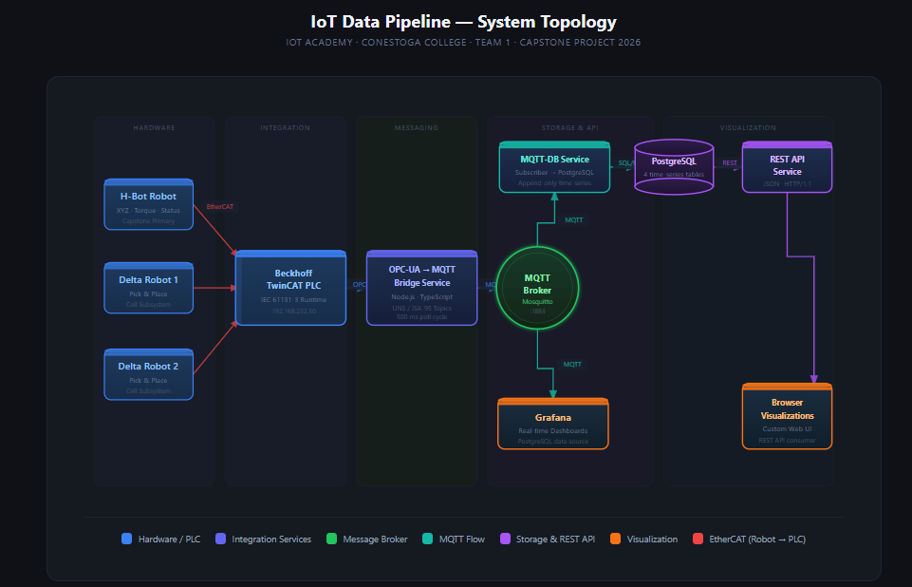

Section 2.1.1: User Interfaces
- Grafana dashboards
- Custom web visualization showing robot status and position

Section 2.1.2: Software Interfaces
- OPC‑UA interface to PLCs
- MQTT broker for message distribution
- Database (SQL or time‑series)
- REST APIs for data access
- Interfacing with team 2’s database to implement APIs
- Interfacing with teams 3’s APIs to implement visualization of Delta Robot #2 positional data

Section 2.1.3: Operations
The system supports continuous monitoring, historical queries, and alert visualization.
- MQTT broker handles asynchronous messaging
- Database stores historical and live data
- Visualization tools poll APIs periodically to display curated data
- Start/Stop functionality
- Manual/search mode- either a pause mode or a way to look up or trend data over a set period to search for any design flaws or errors either in the data or physically with the robot(s) themselves

Section 2.2: Product Functions
The function of this system will be to transmit and record positional and torque data for H-bot, this will include recording the data within a database via an MQTT broker, and visualizing the data using a custom HMI or Grafana to see the extent of the data in terms of accurate positioning and torque values.
High‑level functions include:
- Reading H‑Bot work‑cell, status, position, and torque data
- Publishing robot data to MQTT broker by scraping data from the OPC-UA server
- Storing data from MQTT broker in a structured database
- Providing APIs for visualization
- Displaying robot status and motion via Grafana dashboards and custom web dashboards

Section 2.2.1: Function #1

Overview:
A microservice that scrapes data from the robot work-cell’s existing OPC-UA server and transforms it into the Magna MQTT unified namespace format, and publishes it to the MQTT broker.

Notes:

Actors:
- OPC-UA Server
- OPC-UA -> MQTT microservice
- MQTT Broker
- OT Personnel / Controls Technicians (responsible for maintaining the PLC environment, providing the approved list of OPC-UA tags to be polled, and ensuring the OPC-UA server is operational)

Preconditions:
- OPC-UA service is running and pushing data
- MQTT Broker is reachable and communicating
- Topic namespace is configured
- OPC-UA tag list (node addresses to poll/subscribe) has been provided by OT personnel and loaded into the microservice configuration
- Microservice polling interval configured
Trigger:
- Data acquisition at set interval

Scenario Notes:
Success Outcomes:
H-bot specific positional,torque, and status data successfully transmitted to the MQTT broker.
Normal Flow
- Microservice establishes connection to OPC-UA server.
- The system receives JSON payload from the OPC-UA service.
- Payload is validated and then transformed into Magna-compliant MQTT topic structure.
- Microservice publishes transformed data into MQTT broker topics.
- Broker acknowledges transaction.
- Microservice logs successful publish.
Alternative Flow/Error Handling
- Malformed payload –> logged and discarded
- OPC-UA server unreachable -> attempt to reconnect after set amount of time.
- MQTT Broker unreachable -> microservice queues messages and retries connection after set amount of time.
- Transformation error -> logged and discarded

Section 2.2.2: Function #2

Overview:
A microservice which will subscribe to the MQTT broker for robot status, positional and torque data. Transform into a database-ready format, and then write the data to the database.

Notes:

Actors:
- MQTT Broker
- MQTT -> Database microservice
- Database Server
- Database Administrator (responsible for schema design, access permissions, and ensuring database availability)

Preconditions:
- Database Schema Exists
- MQTT topics and subscriptions active
- Subscribers have correct permissions
- MQTT Broker is reachable
- Database Server is reachable
- Correct database permissions
- MQTT-to-database field mapping configuration defined and loaded (specifying which MQTT topic fields map to which database columns)
Trigger:
- New MQTT Message arrives

Scenario Notes:

Normal Flow:
- Microservice receives MQTT message.
- Message is validated. (topic/payload structure, timestamp)
- Microservice maps MQTT data into database schema fields.
- Data is inserted into the database table.
- Database confirms successful write.
- Microservice logs successful database write.
Alternative Flow/Error Handling:
- Malformed payload -> logged and discarded
- Database unreachable -> Message cached, reconnect attempt after set time interval.
- Data insertion error -> Log error

Section 2.2.3: Function #3

Overview:
Implement REST APIs that extract and serve filtered, structured data from the database to authorized consumers. Consumers may include visualization tools (Grafana, custom UI), AI analytics engines, or any other downstream system requiring access to work-cell and robot data. The API layer decouples data storage from data consumption, ensuring each consumer receives data in the format it requires.

Notes:

Actors:
- API Server
- Database server
- Operators
- Maintenance Personnel
- Engineers
- AI Analytics Engine (optional downstream consumer)
- Visualization Tools / Client Applications (Grafana, custom UI, or other consumers that call the API to retrieve data)

Preconditions:
- API Server Running
- Database populated with data
- API endpoint definitions, authentication configuration, and query parameter schemas are defined and loaded
Trigger:
- Authorized client (visualization tool, AI analytics engine, or other consumer) sends a request to an API endpoint.

API Endpoints (representative examples):
- Work-cell status data (cycle time, part counts, efficiency, conveyor and robot status)
  - Cycle time
  - Part counts
  - Efficiency
  - Status of robots and conveyors
- H-Bot specific data (positional, torque, status time-series)
  - Positional information
  - Torque data

Scenario Notes:
Normal Flow:
- Client sends request to API endpoint
- API validates request parameters.
- API queries database.
- API performs data transformation if necessary.
- API returns response.
- API returns formatted JSON response to client.
Alternative Flow/Error Handling:
- Invalid Parameters -> API returns error
- Database timeout -> API returns error
- No data available -> API returns empty dataset

Section 2.2.4: Function #4

Overview:
Develop Grafana dashboards and a custom web UI visualization that consume data from the APIs (Function #3) to provide real-time and historical views of work-cell status, H-Bot positional data, and torque values. This use case covers the presentation layer; all data access is handled exclusively through the API layer.

Notes:

Actors:
- Grafana Dashboard
- Custom Web UI
- Operators (view real-time work-cell status and robot data)
- Maintenance Personnel (use historical and real-time views for troubleshooting and preventative maintenance)
- Engineers (trend data over time to optimize robot performance)

Preconditions:
- API layer (Function #3) is running and accessible
- Grafana data source and custom UI are configured to point to the correct API endpoints
- Dashboard panel layouts and data bindings configured by the team responsible for visualization design
Trigger:
- User opens a visualization dashboard, or a configured polling interval fires.

UI Mock-ups:
- Include general work-cell information:
  - Cycle time
  - Part counts
  - Efficiency
  - Status of robots and conveyors
- Include H-Bot specific:
  - Positional information
  - Torque data

Scenario Notes:
Normal Flow:
- User opens dashboard or polling interval fires.
- Visualization tool sends request to appropriate API endpoint.
- API returns JSON response.
- Visualization tool parses and renders data as charts, tables, or gauges.
Alternative Flow/Error Handling:
- API unreachable -> Visualization tool displays connection error or stale data indicator
- Empty API response -> Dashboard shows no-data indicator

Section 2.3: User Characteristics
- Operators – View real-time data and visualize cell movements
- Maintenance Technicians – Use historical and real-time data to aid in troubleshooting or preventative maintenance.
- Controls Technicians – Verify data accuracy, and optimize system performance
- Engineers – Use the data to create trends and visualize data to optimize machine performance.

Section 2.4: Constraints
- Limited to PLC tags that are made available. Not all tags from PLC are exposed for full picture.
- Constrained by Team 2 database setup for APIs
- Constrained by Team 3 API setup for data visualization

Section 2.4.1: Regulatory policies

Section 2.4.2: Hardware limitations
- PLC Scan rates
- Network Bandwidth
- PLC tag exposure, not all tags exposed to OPC server.

Section 2.4.3: Interfaces to other applications
- Must follow Magna MQTT Unified Namespace format.
- Interface with Grafana

Section 2.4.4: Parallel Operation
Multiple microservices must run concurrently and must not block each other.

Section 2.4.5: Audit Function
System logs must track:
- Data acquisition errors
- MQTT publish/subscribe events
- Database errors

Section 2.4.6: Control Functions
System is read-only.

Section 2.4.7: Reliability Requirements
- Data acquisition must recover from disconnections.
- MQTT messages must be delivered reliably.

Section 2.4.8: Criticality of the Application
Non-critical. Used for system monitoring and visualization.

Section 2.4.9: Safety and Security Considerations
- No safety concerns.
- Password protection to access database prevents unauthorized access to data
- VPN is used to only allow authorized users access into the system

Section 2.5: Assumptions and Dependencies
- Stable network connection
- Availability of MQTT broker and Database server
- Team 2 to provide Delta Robot Database schema

Section 2.6: Apportioning of Requirements
Stretch goal for graphical representation of end-effector position over top of the conveyor.

Section 2.7: Software System Attributes

AVAILABILITY: Must be continuously available.
RELIABILITY: Should recover from network interruptions automatically. Data must be accurate and timestamped to ensure accurate information is being presented.
SECURITY: Should include authentication so only authorized users can gain access to the data.
MAINTAINABILITY: Must allow modular updates.
PORTABILITY: Could be containerized.

